**LESSON PLAN-02**

**2)**

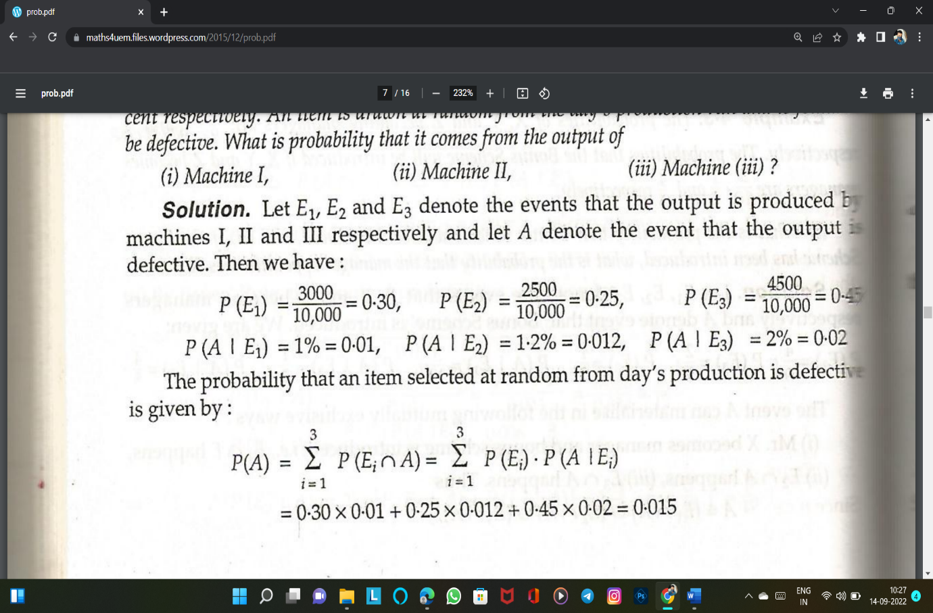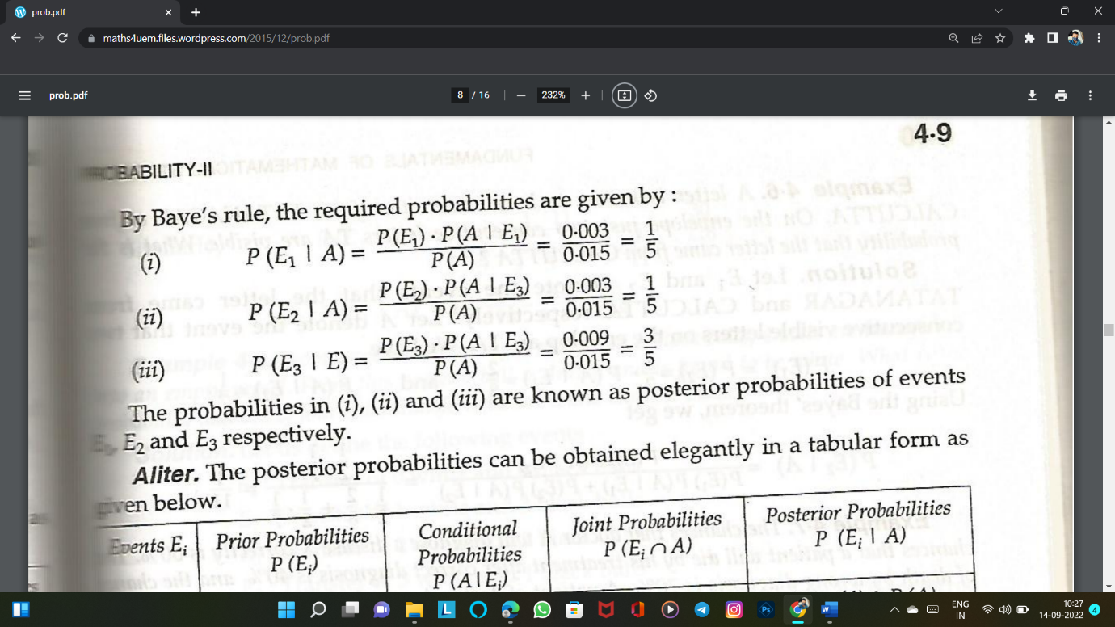3)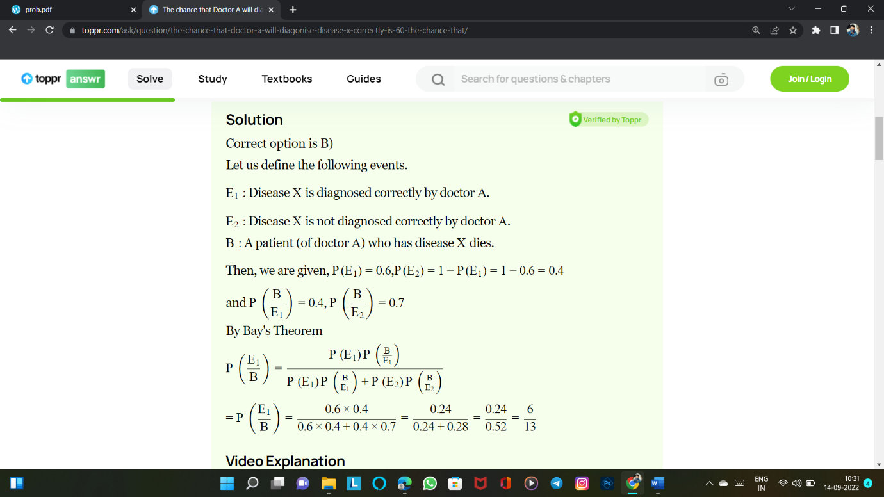

**5)** The white was drawn hence there may be the following possible combinations -

1) 1w 3b - probability = (3C1 X 5C3) / 8C4 = 30/8C4

2) 2w 2b - probability = (3C2 X 5C2) / 8C4 = 30/8C4

3) 3w 1b - probability = (3C3 X 5C1) / 8C4 = 5/8C4

Therefore, the probability of case 3

= (5)/(30+30+5)

= 1/13